

**Trimester: I/II/III Subject: Programming and Problem Solving**

**Name**: Krishnaraj Thadesar **Division:** 9

**Roll No.:** 109054 **Batch:** I3

**Experiment No.:** 1B

**Name of the Experiment:** Algorithm and Flowchart to draw a flowchart to Calculate the volume and area of sphere using given formulas.

**Performed on:** 16nd December 2021

**Submitted on:** 23rd December 2021

**AIM:**

1. Write an algorithm and draw a flowchart to Calculate the volume and area of sphere using the formulas V=4* Pi*r3 /3 and A=4*pi*r2 where r is radius of square of the sphere.

**OBJECTIVE:**

1. To understand importance of flowchart for any programming model.
2. To learn simple flowchart symbols and arrows to define relationships.
3. To understand and develop visual representations of the flow of data.

**THEORY:**

Draw and explain following basic flowchart symbols-

1. Terminal

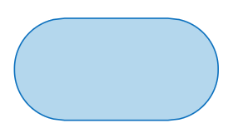

The terminator symbol marks the starting or ending point of the system. It usually contains the word "Start" or "End."

1. Input/output

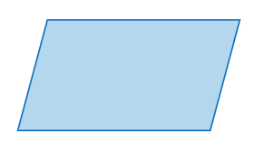

Represents material or information entering or leaving the system, such as customer order (input) or a product (output).

1. Decision

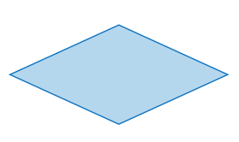

A decision or branching point. Lines representing different decisions emerge from different points of the diamond.

1. Flow lines

**Flow lines** indicate the process' direction. Each **flowline** usually connects two blocks. **Flowlines** can be straight lines, uni-directional arrow, or both-sided arrow.

1. Connectors

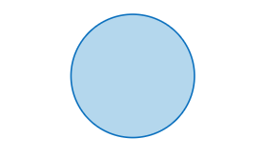

Indicates that the flow continues where a matching symbol (containing the same letter) has been placed.

# PLATFORM: 64 –bit Windows 11.

**INPUT:** Algorithm:

Step 1: Start

Step 2: Declare variables area = 0, volume = 0, PI = 3.14, radius = 0 as floating point numbers.

Step 3: Print "Enter Radius of the Sphere"

Step 4: Input the radius of the Sphere

Step 5: Store the value of radius in the variable radius.

Step 6: Calculate the Volume and assign it to variable volume with formula V=4* Pi*r3/3

Step 7: Calculate the Area of the Sphere and assign it to variable area with formula A=4*pi*r2

Step 8: Print "Volume of Sphere is" volume, and "Area of Sphere is" area.

Step 9: Stop.

Pseudo Code:

*int main(){*

*float volume = 0, area = 0, radius = 0, PI = 3.14*

*print("Enter radius")*

*input(radius)*

*volume = (4/3) * PI * radius * radius*

*area = PI * radius * radius * 4*

*print("Volume is", volume, "Area is", area)*

*}*

**OUTPUT:** Respective flowchart.

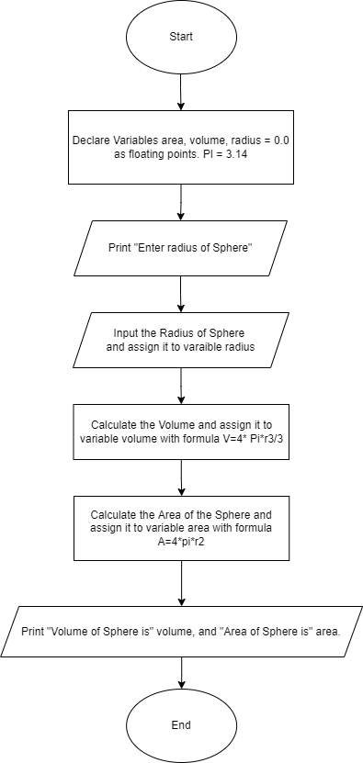

**CONCLUSION:** Thus, learn formalized graphic representation of a given logical sequence.

**FAQ:**

1. Enlist various rules to draw flowchart.

To make sure that a flowchart works, you need to follow a few basic construction rules:

* 1. Each flowchart must have one and only one Start object.
  2. The flow of control must always enter an object from the top.
  3. The flow of control must always leave an object from the bottom (except for Decision objects, which allow the flow of control to leave from the side).
  4. The flow of control must not split. You can use Decision objects to give the flow of control a choice of paths to follow, but it can only follow one of these paths.

1. How to indicate timeframe on a flowchart?

Start with a functional flowchart. Add two columns on the right hand side of the flowchart, labelled cycle time and process time. For each step on the flowchart, measure the process time and cycle time. Record the times in the appropriate columns, aligning with the step in the flowchart.

1. How to show responsibilities on a flowchart?

Responsibilities are represented by the columns on a flowchart. The flowchart symbols are placed within the column of the person or group responsible to complete that item